* 1. **STATIC ROUTING :**

Static routing is also called as “non-adaptive routing”. In this, routing configuration is done manually by the network administrator. The network administrator will have to manually enter the routing information by assessing all the routes.

**STATIC ROUTING PRACTICAL WITH 2 ROUTERS:**

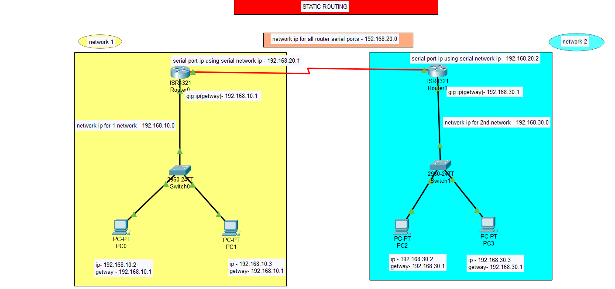

**Command** –

For router-

Router>en

Router#conf t

Router(config)#int gig0/0/0

Router(config-if)#ip add 192.168.10.1 255.255.255.0

Router(config-if)#no shut

Router(config-if)#ex

Router(config)#int se0/1/0

Router(config-if)#ip add 192.168.20.1 255.255.255.0

Router(config-if)#no shut

Router(config)#ip route 192.168.30.0(destination network ip) 255.255.255.0 192.168.20.2(destination serial ip)

Same for next router

>en

Router#conf t

Enter configuration commands, one per line. End with CNTL/Z.

Router(config)#int gig0/0/0

Router(config-if)#ip add 192.168.30.1 255.255.255.0

Router(config-if)#no shut

Router(config-if)#ex

Router(config)#int se0/1/0

Router(config-if)#ip add 192.168.20.2 255.255.255.0

Router(config-if)#no shut

Router(config)#ip route 192.168.10.0(starting network ip) 255.255.255.0 192.168.20.1(sender serial ip)

* Then configure all pc’s put the getways.
* Command process and pc configure process will done then open the pc command line and ping the all pc . check the all pc’s ping successfully.

**FOR 3 ROUTER =**

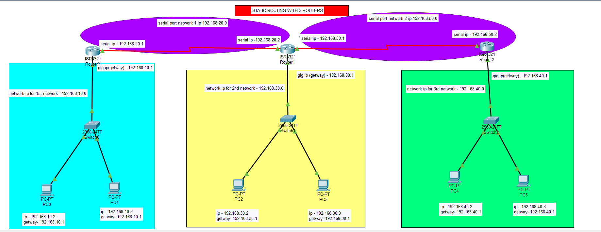

COMMANDS-

ROUTER 1

Router>en

Router#conf t

Enter configuration commands, one per line. End with CNTL/Z.

Router(config)#int gig0/0/0

Router(config-if)#ip add 192.168.10.1 255.255.255.0

Router(config-if)#no shut

Router(config-if)#ex

Router(config)#int se0/1/0

Router(config-if)#ip add 192.168.20.1 255.255.255.0

Router(config-if)#no shut

Router(config-if)#ex

Router(config)#ip route 192.168.30.0 255.255.255.0 192.168.20.2

Router(config)#ip route 192.168.50.0 255.255.255.0 192.168.20.2

Router(config)#ip route 192.168.40.0 255.255.255.0 192.168.20.2

FOR ROUTER 2

Router>en

Router#conf t

Enter configuration commands, one per line. End with CNTL/Z.

Router(config)#int gig0/0/0

Router(config-if)#ip add 192.168.30.1 255.255.255.0

Router(config-if)#no shut

Router(config-if)#ex

Router(config-if)#int se0/1/0

Router(config-if)#ip add 192.168.20.2 255.255.255.0

Router(config-if)#no shut

Router(config-if)#ex

Router(config)#int se0/1/1

Router(config-if)#ip add 192.168.50.1 255.255.255.0

Router(config-if)#no shut

Router(config-if)#ex

Router(config)#ip route 192.168.10.0 255.255.255.0 192.168.20.1

Router(config)#ip route 192.168.40.0 255.255.255.0 192.168.50.2

FOR ROUTER 3

Router>en

Router#conf t

Enter configuration commands, one per line. End with CNTL/Z.

Router(config)#int gig0/0/0

Router(config-if)#ip add 192.168.40.1 255.255.255.0

Router(config-if)#no shut

Router(config-if)#ex

Router(config)#int se0/1/0

Router(config-if)#ip add 192.168.50.2 255.255.255.0

Router(config-if)#no shut

Router(config-if)#ex

Router(config)#ip route 192.168.30.0 255.255.255.0 192.168.50.1

Router(config)#ip route 192.168.20.0 255.255.255.0 192.168.50.1

Router(config)#ip route 192.168.10.0 255.255.255.0 192.168.50.1